KESGRAVE AND RUSHMERE ST. ANDREW
Partnership Funded PCSO Report – January 2021
By PCSO 3357 Eleanor Miles

Woodbridge Safer Neighbourhood Team

Welcome to my monthly Partnership Funded PCSO report for January 2021

UPDATES:

Firstly, I just want to wish everyone a Happy New Year! I know that 2020 was a very strange year, but I am hopeful that 2021 will bring a lot more positivity for everyone and, in time, we start to get back to some level of normality.

Current Restrictions
Due to the current COVID-19 restrictions, Police have been receiving a number of calls relating to possible breaches across the local area. We will be continuing to attend these locations and engage with members of the public, enforcing through fixed penalty notices when necessary. I will also be patrolling around the parish on foot, giving words of advice and ticketing those breaking the lockdown laws if required.

Anti-Social Behaviour
Whilst reports of ASB are low for the area, there are a couple of areas that have experienced issues over the last month, namely Bladen Drive and Rushmere Golf Club. I have spoken to some local residents regarding these issues and this has been raised with the local SNT to continue patrolling these areas where possible.

As always, should you have any concerns relating to anti-social behaviour, breach of the current COVID restrictions or any other police matter, please continue to report this through the relevant channels.

POLICE ADVICE AND GUIDANCE

I am always happy to give advice and guidance where I can. If it is something that I cannot give an immediate answer too, I am ideally placed to seek advice from other professionals. Members of the public wanting advice on many police-related matters can be signposted to the Suffolk Constabulary website advice page at https://www.suffolk.police.uk/advice

Remember – call 999 in an emergency or if there is a crime in progress, otherwise call 101 or report online via https://www.suffolk.police.uk/contact-us/report-something

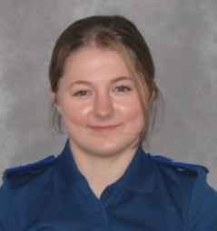
Eleanor Miles
Police Community Support Officer 3357
Match funded PCSO for Kesgrave and Rushmere St. Andrew
Woodbridge SNT Base
Tel. 101 (non-emergency number)
eleanor.miles@suffolk.pnn.police.uk
www.suffolk.police.uk

