KESGRAVE AND RUSHMERE ST. ANDREW
Partnership Funded PCSO Report – August 2020
By PCSO 3357 Eleanor Miles

Woodbridge Safer Neighbourhood Team

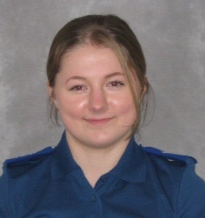 Welcome to my monthly Partnership Funded PCSO report for August 2020

UPDATES:

Anti-Social Behaviour
Whilst there does seem to be a decrease in reports of anti-social behaviour in the Rushmere St. Andrew, I am continuing to patrol the areas of interest, including Bladen Drive and Gwendoline Close after several reports of ASB. I am working alongside other members of the local SNT in order to monitor the area and deal with any nuisance behaviour where necessary.

If you are experiencing issues in your area with anti-social behaviour, please report this via 101 or the online reporting function.
https://www.suffolk.police.uk/contact-us/report-something/6-report-anti-social-behaviour

Speeding
Due to increasing reports of speeding in the area, myself and other members of Heath Road SNT have been conducting speed checks on Playford Road, giving words of advice and ticketing where applicable. This has been well received by local residents who have been having issues with cars driving at speeds in excess of 30mph.

Back to School
As children start to go back to school, I will be showing some police presence around the area at key times in order to engage with staff, parents and children should they be experiencing any issues.

POLICE ADVICE AND GUIDANCE

I am always happy to give advice and guidance where I can. If it is something that I cannot give an immediate answer too, I am ideally placed to seek advice from other professionals. Members of the public wanting advice on many police-related matters can be signposted to the Suffolk Constabulary website advice page at https://www.suffolk.police.uk/advice

Eleanor Miles
Police Community Support Officer 3357
Match funded PCSO for Kesgrave and Rushmere St. Andrew
Woodbridge SNT Base
Tel. 101 (non-emergency number)
eleanor.miles@suffolk.pnn.police.uk
www.suffolk.police.uk

