RUSHMERE ST ANDREW NEIGHBOURHOOD PLAN

YOUNG PEOPLE AND YOUTH QUESTIONNAIRE

ABOUT YOURSELF

1. PLEASE GIVE YOUR AGE (AS AT 1ST JANUARY 2021)
 |  | Response Percent | Response Total
1 |  | 0.00% | 0
2 |  | 0.00% | 0
3 |  | 0.00% | 0
4 |  | 0.00% | 0
5 |  | 0.00% | 0
6 |  | 0.00% | 0
7 |  | 0.00% | 0
8 |  | 0.00% | 0
9 |  | 9.09% | 1
10 |  | 27.27% | 3
11 |  | 18.18% | 2
12 |  | 0.00% | 0
13 |  | 9.09% | 1
14 |  | 0.00% | 0
15 |  | 0.00% | 0
16 |  | 18.18% | 2
17 |  | 18.18% | 2
 |  | answered | 11
 |  | skipped | 1

 | skipped | 1

3. PLEASE MARK WHICH APPLIES
 |  |  | Response Percent | Response Total
1 | At Pre-School |  | 0.00% | 0
2 | At Primary School |  | 45.45% | 5
3 | At High School |  | 36.36% | 4
4 | At Sixth Form/ College/ University |  | 18.18% | 2
5 | At Work |  | 0.00% | 0
6 | Looking for Work |  | 0.00% | 0
 |  |  | answered | 11
 |  |  | skipped | 1

4. PLEASE MARK WHICH APPLIES. IN ORDER TO GET TO SCHOOL / COLLEGE OR WORK:
 |  |  | Response Percent | Response Total
1 | I usually walk |  | 27.27% | 3
2 | I usually cycle |  | 9.09% | 1
3 | I usually get taken by car or private transport |  | 54.55% | 6
4 | I usually catch a bus and/ or go by train |  | 0.00% | 0
5 | I drive myself |  | 9.09% | 1
 |  |  | answered | 11
 |  |  | skipped | 1
Any other means (1)
1 | Cycle and walk. Depends on the access route is blocked by weather conditions

HOUSING

5. Please tick Yes, No or Not Sure in the table below
 | Yes | No | Not Sure | Response Total
I like the house I live in | 100.0%  (11) | 0.0%  (0) | 0.0%  (0) | 11
I like the road and area I live in | 90.9%  (10) | 9.1%  (1) | 0.0%  (0) | 11
I could see myself living in Rushmere St Andrew for many years to come | 27.3%  (3) | 0.0%  (0) | 72.7%  (8) | 11
 |  |  | answered | 11
 |  |  | skipped | 1

5.1. I like the house I live in |  |  | Response Percent | Response Total
1 | Yes |  | 100.0% | 11
2 | No |  | 0.0% | 0
3 | Not Sure |  | 0.0% | 0
 |  |  | answered | 11

5.2. I like the road and area I live in |  |  | Response Percent | Response Total
1 | Yes |  | 90.9% | 10
2 | No |  | 9.1% | 1
3 | Not Sure |  | 0.0% | 0
 |  |  | answered | 11

5.3. I could see myself living in Rushmere St Andrew for many years to come |  |  | Response Percent | Response Total
1 | Yes |  | 27.3% | 3
2 | No |  | 0.0% | 0
3 | Not Sure |  | 72.7% | 8
 |  |  | answered | 11

6. We’d like to hear any comments you wish to add to your answers to questions above
1 | Road is very busy
2 | I dislike my road because it’s very busy and muddy all of the time.

 | answered | 2
 | skipped | 10

7. Thinking of homes for the future please help us by answering the following:
 | Agree | Response Total
There should be new starter homes for young people | 100.0%  (11) | 11
There should be flats or apartments in Rushmere St Andrew | 100.0%  (2) | 2
There should be homes for the elderly to move into, in order to "free up" family homes | 100.0%  (7) | 7
There should be large houses with plenty of bedrooms | 100.0%  (10) | 10
 | answered | 11
 | skipped | 1

7.1. There should be new starter homes for young people |  |  | Response Percent | Response Total
1 | Agree |  | 100.0% | 11
 |  |  | answered | 11

7.2. There should be flats or apartments in Rushmere St Andrew |  |  | Response Percent | Response Total
1 | Agree |  | 100.0% | 2
 |  |  | answered | 2

7.3. There should be homes for the elderly to move into, in order to "free up" family homes |  |  | Response Percent | Response Total
1 | Agree |  | 100.0% | 7
 |  |  | answered | 7

7.4. There should be large houses with plenty of bedrooms |  |  | Response Percent | Response Total
1 | Agree |  | 100.0% | 10
 |  |  | answered | 10

8. Now, thinking about the construction:
 | Agree | Response Total
All new houses should have solar panels/ triple glazed windows, etc | 100.0%  (9) | 9
All new houses should have electric car charging points | 100.0%  (9) | 9
All new houses should have secure cycle storage | 100.0%  (9) | 9
 | answered | 10
 | skipped | 2

9. What other ideas do you have regarding homes for the future?
1 | Big gardens
2 | ground water pumps to help with heating.  water capture schemes, such as grey water tanks, for more a more sustainable water supply.
3 | Large gardens not crowded

 | answered | 3
 | skipped | 9

ROADS AND TRANSPORT

10. Most of you answering this survey will not yet have use of your own car or motorcycle. It helps to shape ideas for a Neighbourhood Plan with your responses to the following: Please tick those which apply to you:
 | Agree | Response Total
I am dependent on my family / carers for transport to and from Rushmere St Andrew | 100.0%  (8) | 8
I walk to school/ college/ work | 100.0%  (4) | 4
I cycle to school/ college/ work | 100.0%  (2) | 2
I travel to school/ college/ work by bus/ train | 100.0%  (1) | 1
I use a motorcycle/ car to get to school/ college/ work | 100.0%  (3) | 3
My school / college / workplace is in the parish | 100.0%  (2) | 2
My school / college / workplace is outside the parish | 100.0%  (8) | 8
 | answered | 11
 | skipped | 1

11. Please give a brief location where you travel to school / college / work (eg. Ipswich, Martlesham etc). We do NOT need the name of the school / college / place of work.
1 | Ipswich
2 | Only takes 10 minutes to walk to school
3 | Ipswich
4 | Pinewood/ South West Ipswich
5 | Rushmere
6 | Ipswich
7 | Ipswich
8 | Copleston
9 | Martlesham
10 | Ipswich

 | answered | 10
 | skipped | 2

12. It’s very important that future plans for Rushmere St Andrew shape your locality in terms of your enjoyment and safety. Please tick Yes or No:
 | Yes | No | Response Total
I feel safe walking along the footpaths where I live | 100.0%  (11) | 0.0%  (0) | 11
I feel safe cycling to and from school/ work/ college | 77.8%  (7) | 22.2%  (2) | 9
I feel safe going out on my own in Rushmere St Andrew | 90.9%  (10) | 9.1%  (1) | 11
I think Rushmere is a good place where to grow up | 100.0%  (11) | 0.0%  (0) | 11
 |  | answered | 11
 |  | skipped | 1

12.1. I feel safe walking along the footpaths where I live |  |  | Response Percent | Response Total
1 | Yes |  | 100.0% | 11
2 | No |  | 0.0% | 0
 |  |  | answered | 11

12.2. I feel safe cycling to and from school/ work/ college |  |  | Response Percent | Response Total
1 | Yes |  | 77.8% | 7
2 | No |  | 22.2% | 2
 |  |  | answered | 9

12.3. I feel safe going out on my own in Rushmere St Andrew |  |  | Response Percent | Response Total
1 | Yes |  | 90.9% | 10
2 | No |  | 9.1% | 1
 |  |  | answered | 11

12.4. I think Rushmere is a good place where to grow up |  |  | Response Percent | Response Total
1 | Yes |  | 100.0% | 11
2 | No |  | 0.0% | 0
 |  |  | answered | 11

13. Please explain further if you answered no in the table above
1 | really safe and family oriented area. Always felt safe here and the access to green space is lovely for young children living in this suburb.
2 | The roads are too busy and there are not enough cycle lanes to feel safe on. I wish we had more lanes like Kesgrave then Mum would let us cycle to school.
3 | The field I cross to get to school is often flooded

 | answered | 3
 | skipped | 9

14. Again, if you answered "no", what would be your ideas to solve the issue that makes you feel unsafe:
1 | putting in cycle lanes and slowing down traffic. It was better in lockdown- we went on our bikes a lot.
2 | I think the footpath needs to be accessible

 | answered | 2
 | skipped | 10

15. Finally, do you have any additional comments on any aspect of roads and transport in Rushmere St Andrew?
1 | Bixley Drive (opposite Pardoe Place) usually has cars parked on the road. With this part of the road being a hill and blind corner, i feel it is quite a danger, and as a young driver, i try to avoid this road as a collision could easily occur. I am aware that the houses along this section of the road do not have enough parking, however i feel that parking on the road here is quite dangerous.
2 | it would be good to have a train station stop as the train goes right by rushmere.
3 | It’s dangerous to cross the road to get to school. The speed of cars is fast. We always have to look several times before crossing. My mum won’t let me go to schools on my own because of this reason.

 | answered | 3
 | skipped | 9

THE ENVIRONMENT AND LANDSCAPE

16. What do you understand by the term "Environment"?
1 | Area around where I live
2 | The place we live in
3 | I am an A-Level Geography student, so i believe it means many different things. I think with more building in urban areas, it is so important to keep aspects of the natural environment in tact, not only for the health of the planet we live on, but also for the health and well-being of humans.
4 | The nature surrounding the area.
5 | the world around us.
6 | T
7 | The world around you. Nature (trees, birds), people (living, working, travelling) buildings.
8 | Our surroundings, nature, atmosphere

 | answered | 8
 | skipped | 4

17. How important is it to you that we protect trees and hedgerows around where you live?
 |  |  | Response Percent | Response Total
1 | Very Important |  | 72.73% | 8
2 | Important |  | 27.27% | 3
3 | Not Very Important |  | 0.00% | 0
4 | Not At All Important |  | 0.00% | 0
 |  |  | answered | 11
 |  |  | skipped | 1

18. How important is it to you to protect wild animals such as birds, bees, butterflies?
 |  |  | Response Percent | Response Total
1 | Very Important |  | 72.73% | 8
2 | Important |  | 27.27% | 3
3 | Not Very Important |  | 0.00% | 0
4 | Not At All Important |  | 0.00% | 0
 |  |  | answered | 11
 |  |  | skipped | 1

19. Have you seen any of the following recently (either in your garden or near where you live?) Please tick all that apply:
 | YES | Response Total
Any species of bird | 100.0%  (9) | 9
Any butterfly | 100.0%  (9) | 9
Any type of bee or wasp | 100.0%  (9) | 9
A fox | 100.0%  (4) | 4
A hedgehog | 100.0%  (3) | 3
 | answered | 10
 | skipped | 2
Any other wild animal (4)
1 | Deer
2 | Deer in my garden
3 | Deer
4 | squirrel, frog.

20. In and around Rushmere St Andrew there are several areas of countryside set aside to encourage nature which are easy to access. Please tick all those you know about:
 | Know about | Response Total
Rushmere Heath | 100.0%  (9) | 9
The Sandlings (football goal area and surrounding land) | 100.0%  (9) | 9
The Millstream Local Nature Reserve | 100.0%  (7) | 7
Bixley Heath Nature Area | 100.0%  (7) | 7
Rushmere Village Ponds | 100.0%  (8) | 8
River Fynn Valley (sometimes known as "Tuddenham Stream") | 100.0%  (6) | 6
 | answered | 11
 | skipped | 1

21. For the ones you’ve ticked in the table above please say how often you visit:
 | Occasionally | Often | Never | Response Total
Rushmere Heath | 36.4%  (4) | 54.5%  (6) | 9.1%  (1) | 11
The Sandlings (football goal area and surrounding land) | 27.3%  (3) | 54.5%  (6) | 18.2%  (2) | 11
The Millstream Local Nature Reserve | 36.4%  (4) | 36.4%  (4) | 27.3%  (3) | 11
Bixley Heath Nature Area | 36.4%  (4) | 27.3%  (3) | 36.4%  (4) | 11
Rushmere Village Ponds | 45.5%  (5) | 36.4%  (4) | 18.2%  (2) | 11
River Fynn Valley (sometimes known as "Tuddenham Stream") | 9.1%  (1) | 45.5%  (5) | 45.5%  (5) | 11
 |  |  | answered | 11
 |  |  | skipped | 1

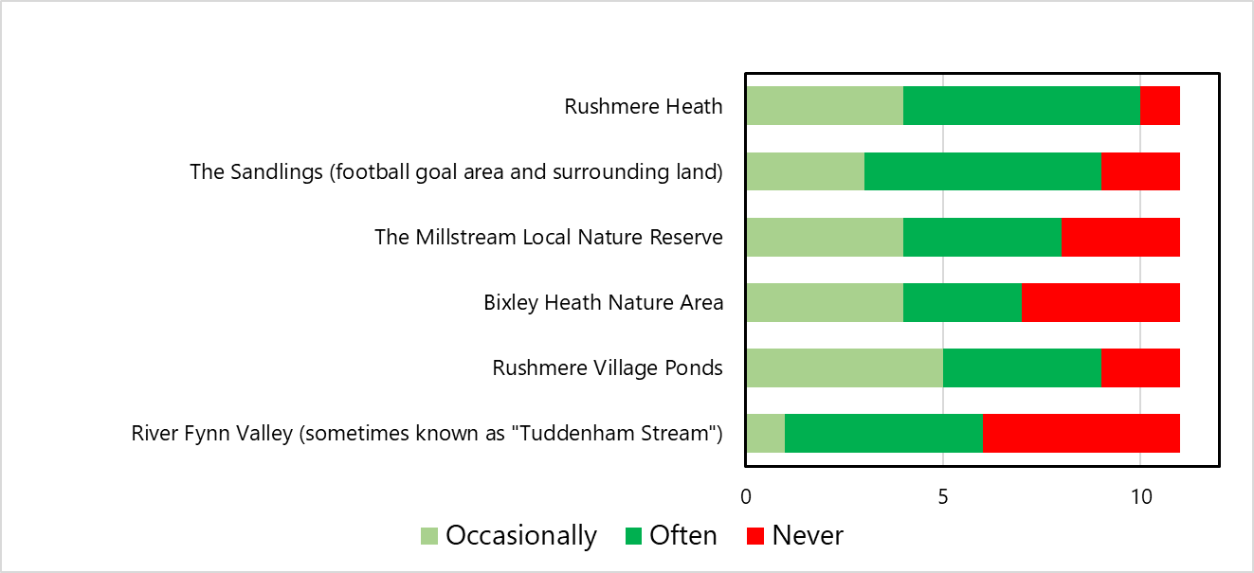

AMENITIES AND FACILITIES

22. Rushmere St Andrew Parish Council is responsible for several play areas. Please tick those you know about (tick all that apply to you):
 | Know about | Response Total
Chestnut Play Area | 100.0%  (5) | 5
Kelvedon Play Area | 100.0%  (5) | 5
Yewtree Play Area | 100.0%  (3) | 3
Tower Hall Play Area | 100.0%  (9) | 9
Broke Hall Playing Field | 100.0%  (7) | 7
Sandlings (Football Goal Area) | 100.0%  (9) | 9
 | answered | 11
 | skipped | 1

23. For the ones you ticked please indicate your use of them:
 | Daily | Once a week | Once or twice a month | Rarely | Response Total
Chestnut Play Area | 0.0%  (0) | 0.0%  (0) | 12.5%  (1) | 87.5%  (7) | 8
Kelvedon Play Area | 0.0%  (0) | 0.0%  (0) | 20.0%  (1) | 80.0%  (4) | 5
Yewtree Play Area | 0.0%  (0) | 0.0%  (0) | 40.0%  (2) | 60.0%  (3) | 5
Tower Hall Play Area | 0.0%  (0) | 12.5%  (1) | 50.0%  (4) | 37.5%  (3) | 8
Broke Hall Playing Field | 0.0%  (0) | 14.3%  (1) | 42.9%  (3) | 42.9%  (3) | 7
Sandlings (Football Goal Area) | 0.0%  (0) | 11.1%  (1) | 22.2%  (2) | 66.7%  (6) | 9
 |  |  |  | answered | 11
 |  |  |  | skipped | 1

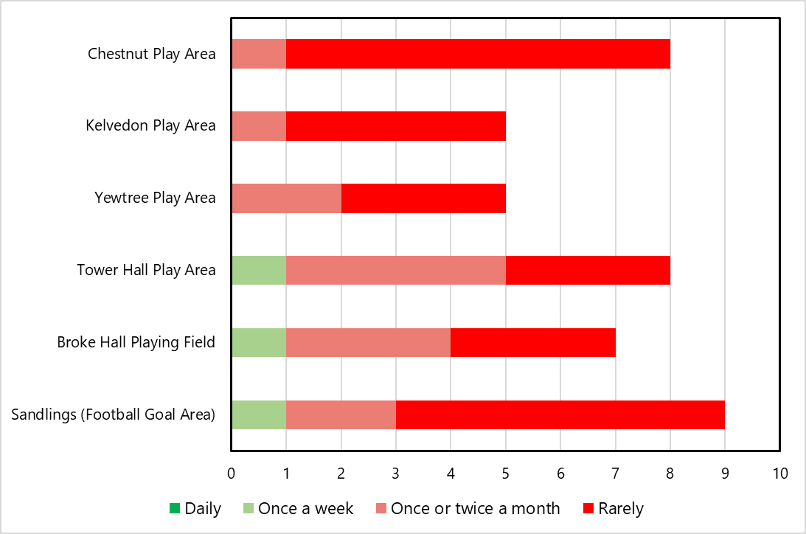

24. Some of our Play Spaces have Adult Fitness Equipment. Is it something you’ve used:
 |  |  | Response Percent | Response Total
1 | Often |  | 18.18% | 2
2 | Sometimes |  | 45.45% | 5
3 | Rarely |  | 0.00% | 0
4 | Never |  | 36.36% | 4
 |  |  | answered | 11
 |  |  | skipped | 1

25. It’s really important that we develop facilities suitable for all age groups. Please help us to understand the needs of local youngsters. Tick all those which apply:
 | Agree | Response Total
There needs to be more equipment for very young children | 100.0%  (3) | 3
There needs to be more equipment for children up to 12 years old | 100.0%  (7) | 7
There needs to be more facilities for youngsters aged 12 and over | 100.0%  (10) | 10
There needs to be more play/ recreation facilities in Rushmere Village | 100.0%  (8) | 8
There needs to be more play/ recreational facilities in Bixley and Broke Hall | 100.0%  (5) | 5
There needs to be more play/recreational facilities for disabled children | 100.0%  (7) | 7
I think the play areas we have in Rushmere St Andrew are about right | 100.0%  (3) | 3
 | answered | 11
 | skipped | 1

26. Please suggest ways to improve facilities / types of facilities to provide in the area:
 |  | Response Percent | Response Total
1 | Open-Ended Question | 100.00% | 2
1 | Need more facilities for teenagers
2 | the play areas in Ipswich have been improved recently- when will we improve the ones in rushmere to have more play equipment for older children?  I would like a football pitch in this side of the village to play on with my friends.

 |  | answered | 2
 |  | skipped | 10

27. If you are a user of the local play areas how do you feel about these issues? (Please tick all that apply)
 | Agree | Response Total
I feel safe when I visit the play areas | 100.0%  (7) | 7
All the equipment is in good condition | 100.0%  (6) | 6
The areas are kept clean of litter | 100.0%  (6) | 6
There’s room for everyone no matter what age you are | 100.0%  (4) | 4
 | answered | 8
 | skipped | 4

